**Assisted Practice: 4.2 Push an Image to Docker Hub**

This section will guide you to**:**

* Build a custom Docker image using basic code of Python and push it to Docker Hub.

This lab has three subsections, namely**:**

4.2.1 Preparing a custom Docker image

4.2.2 Pushing the Docker image to Docker Hub

4.2.3 Push the code to GitHub repositories

* Docker is already installed in your lab. (Refer FSD: Lab Guide - Phase 5)

**Step 4.2.1:** Preparing a custom Docker image:

* Create a directory and write basic Python source code using the procedure given below:

mkdirdocker_python

cddocker_python/

vi Dockerfile

* Add the code given below to this Dockerfile

FROM python  
WORKDIR /app  
ADD . /app  
RUN pip install -r requirements.txt  
EXPOSE 80  
ENV NAME world  
CMD [“python”, “app.py”]

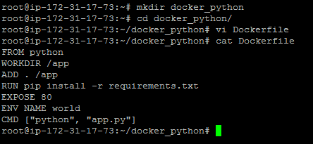

* Create a Python app. Follow the steps below to create an app.py python file

vi app.py

* Add the content below in app.py python source file

from flask import Flask  
import os  
import socket  
app = Flask(__name__)[@app](http://twitter.com/app).route(“/”)def hello():  
 html = “<h3>Hello {name}!</h3>” \  
 “<b>Hostname:</b> {hostname}<br/>”  
 return html.format(name=os.getenv(“NAME”, “world”), hostname=socket.gethostname())  
if __name__ == “__main__”:  
app.run(host=’0.0.0.0', port=80)

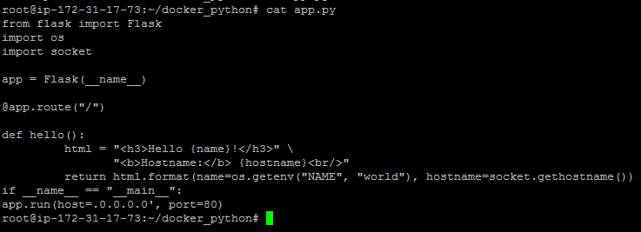

* Create a **requirements.txt** file with the content below

vi requirements.txt

Flask

* You will get the file mentioned below for building a custom Docker image

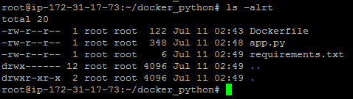

* Proceed with docker build command to build a custom Docker image

dockerbuild -t docker_python . -f Dockerfile

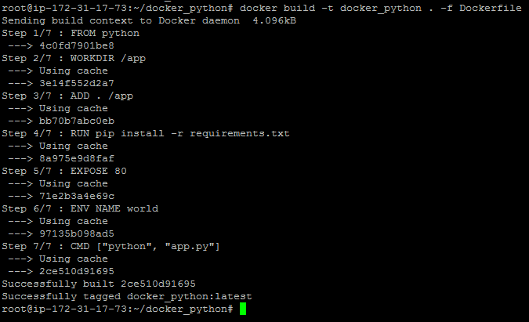

* Once the image is built, check the image using **docker run** command and run it to initialize the custom container on Docker host.

docker images

docker run -d --name docker_python-p 80:80 docker_python

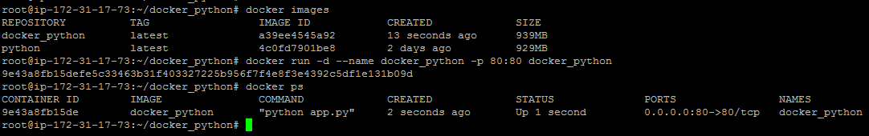

* Once the container is up and running, validate the connectivity using the **curl** command to see if Python code is running on port 80 or not.

curl localhost



**Step 4.2.2:** Pushing Docker image to Docker Hub

* Once the Docker image is prepared, we need to push this custom Docker image to Docker Hub.
* For pushing the image to Docker Hub, create an account on Docker Hub. Follow simple sign up process to create a new account.

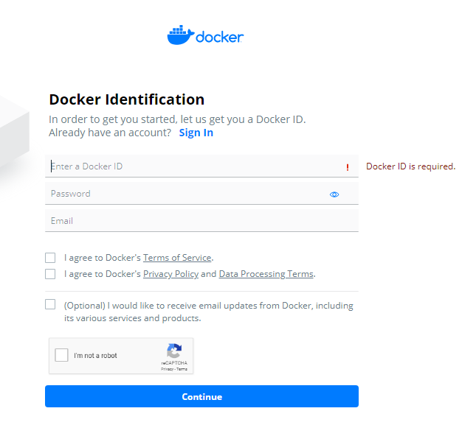

* Once the account is created, we need to login to Docker Hub to push the Docker image to Docker Hub.

docker login

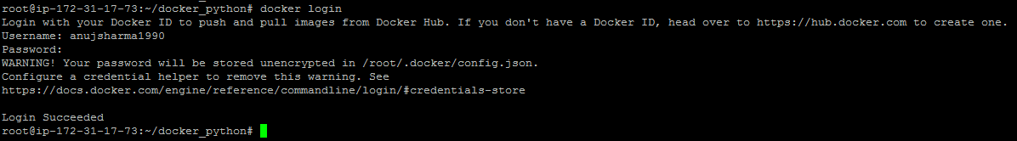

* Create a tag that can be used to push the custom image to Docker Hub.

docker tag docker_python anujsharma1990/docker_python

docker push anujsharma1990/docker_python

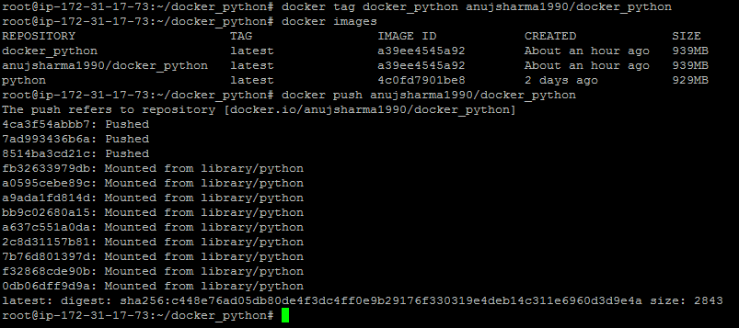

* Shown below is the uploaded custom Docker image to Docker Hub.

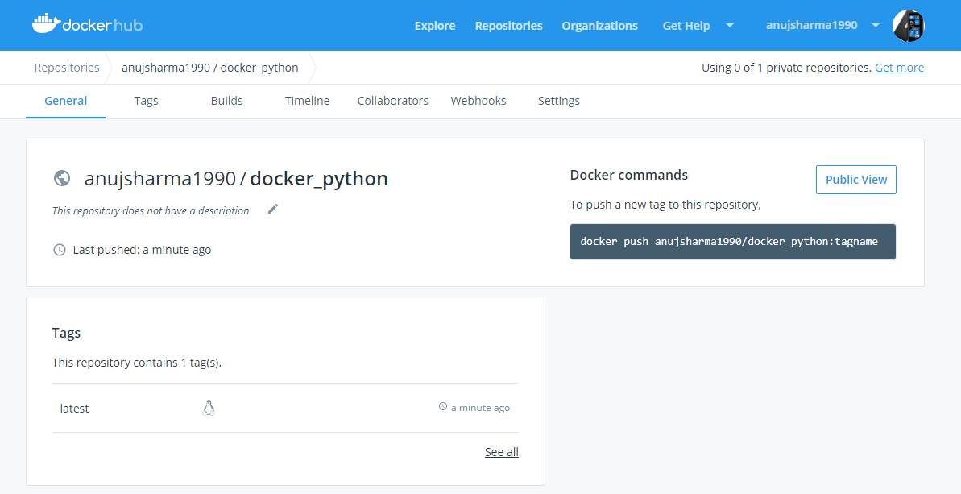

**Step 4.2.3:** Pushing the code to your GitHub repositories

* Open your command prompt and navigate to the folder where you have created your files.

**cd <folder path>**

* Initialize your repository using the following command:

**git init**

* Add all the files to your git repository using the following command:

**git add .**

* Commit the changes using the following command:

**git commit . -m “Changes have been committed.”**

* Push the files to the folder you initially created using the following command:

**git push -u origin master**